Merge Two Sorted Linked List (with head node)

Description
The program takes two lists, each of which is sorted in increasing order, and merges the two together into one list which is in increasing order. The new list should be made by splicing together the nodes of the first two lists.
Note that you are supposed to use singly linked list with head node to store the structure in the program. Besides, C++ program is NOT mandatory for completing this exercise, which means you have the option of C or C++ program.
Time Limit: 3000ms, Memory Limit: 10000KB.

Input
- First line – the length of the first sorted linked list, which is an integer 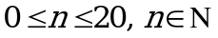;
- Second line -- the numbers belonging to the first sorted linked list which are separated by spaces;
- Third line -- the length of the second sorted linked list, which is an integer 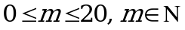;
- Forth line -- the numbers belonging to the second sorted linked list which are separated by spaces.

Output
The merged sorted linked list. Print each number on a separate line.

Sample Input
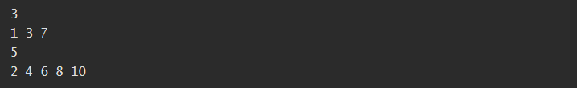

Sample Output


Submission
Submit all the source code files.

